**PRACTICAL NUMBER 1**

**AIM :** Write a program to implement MongoDB data models.

1. Create a database named as empdb with collection name emp.

**Embedded Data Model :**

**CODE :**

use empdb

db.createCollection("empdb")

db.empdb.insert({

name : "Shehzad",

age : 18,

email : "shehzad@gmail.com",

detail : [{contact : 9999988888, FamilyMember :"Five"},

{contact : 8888899999 , FamilyMember : "Three"}]

})

**OUTPUT :**

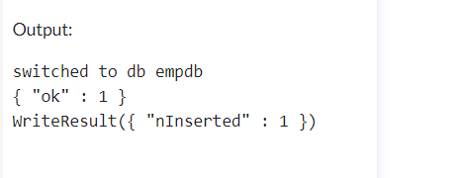

**Normalized Data Model :**

**CODE :**

db.empdb.insert({

name : "shehzad",

age : 18,

website : "empCompany.com"

})

db.empdb.find()

**OUTPUT :**

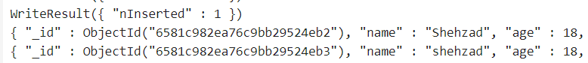

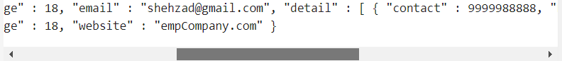

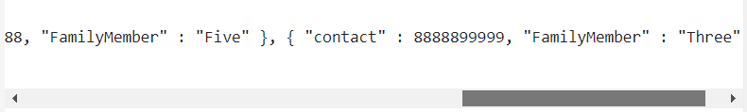

**PRACTICAL NUMBER 2**

**AIM :** Write a program to implement CRUD operation on MongoDB.

1. **Create Operation**

**CODE :**

use student

db.createCollection("student")

OUTPUT :

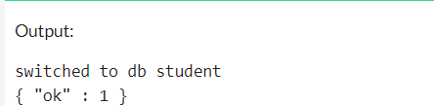

1. Insert()

**CODE :**

db.student.insert({

name : "aamina",

age : "19",

roll_no : "221"

})

**OUTPUT :**

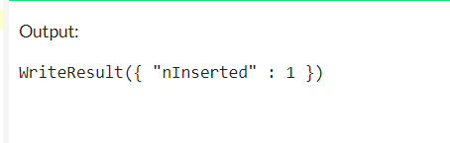

1. insertMany()

**CODE :**

db.student.insertMany([{

name : "aamina",

age : "19",

roll_no : "221"},

{

name : "priyanka",

age : "19",

roll_no : "222"},

{

name : "karishma",

age : "20",

roll_no : "223"}

])

**OUTPUT :**

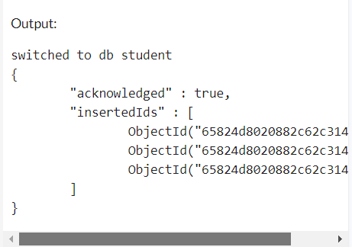

1. **Read Operation:**
2. find()

**CODE :**

db.student.find()

**OUTPUT :**

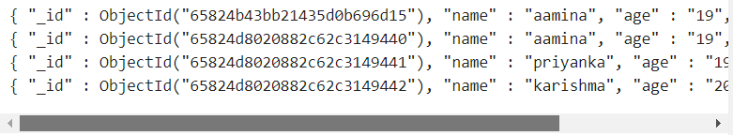

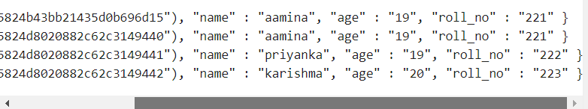

1. findOne()

**CODE :**

db.student.insertMany([{

name :"aamina",

age :"19",

roll_no :"221"},

{

name :"priyanka",

age :"19",

roll_no :"222"},

{

name :"karishma",

age :"20",

roll_no :"223"}

])

db.student.findOne({name :"aamina"})

**OUTPUT :**

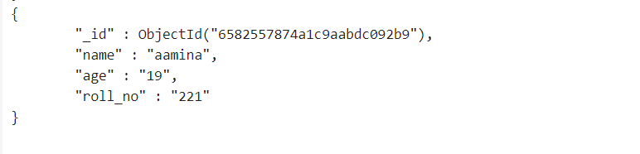

1. **Update Operation**
2. updateOne()

**CODE :**

db.student.updateOne({name : "priyanka"},{$set:{age : "21"}})

db.student.find()

**OUTPUT :**

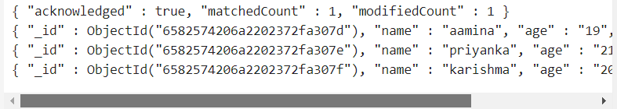

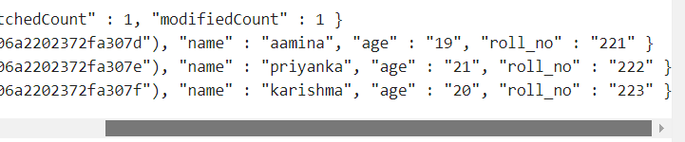

1. **Delete Operation**
2. deleteOne()

**CODE :**

db.student.deleteOne({name:"aamina"})

db.student.find()

**OUTPUT :**

